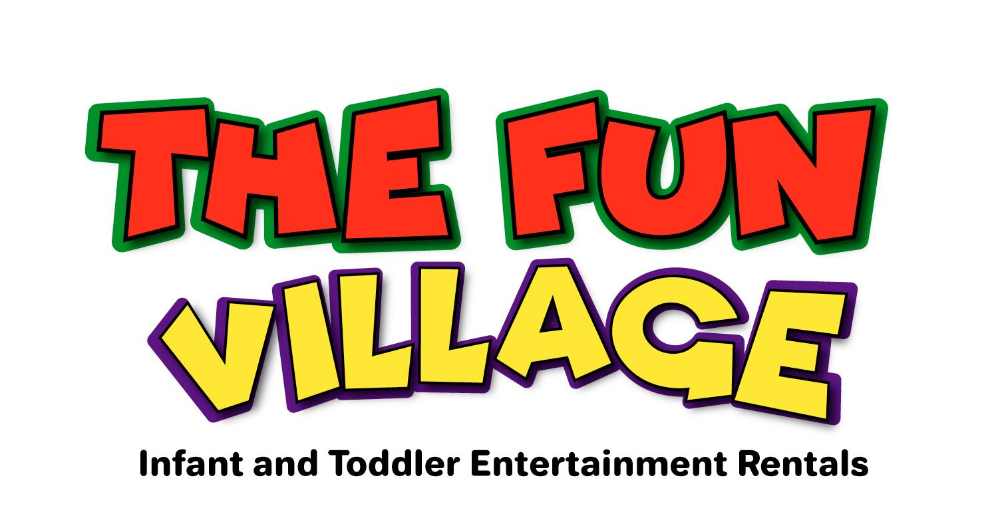
Austell, Georgia 30106

The Fun Village The Fun Village The Fun Village

Rental Agreement

1) This soft play equipment, toddler toys and bounce house has been received in good condition and will be returned in the same condition.

2) Customer agrees to allow The Fun Village the right to enter premises of customer at any time to
repossess said soft play equipment.

3) Customer agrees to reimburse The Fun Village for all attorney fees, an amount not less than 50% of all sums due, court cost and expenses incurred by The Fun Village to enforce collection or to preserve or enforce rights under this contract.

4) Customer agrees not to loan, sublet or otherwise dispose of soft play equipment or use it at any other
Location.

5) Customer agrees to pay in full the replacement cost, including labor, for all damages to soft play equipment.

6) If the soft play equipment is lost, stolen, or damaged beyond repair, the renter agrees to pay up to
$3000.00(Three thousand dollars and 0 cents)

7) Customer agrees to ensure that all users (and users’ guardians) of the rental go over and read all rules.

8) THERE ARE NO WARRANTIES OF MERCHANTABILITY OR FITNESS EITHER EXPRESSED OR
IMPLIED. The person/s or organization renting this Soft Play Equipment, Play Toys,and or Bounce Houses from The Fun Village will be held responsible and liable for any and all damage or injury occurring for any reason whatsoever. I have read the above agreement and fully understand and accept the conditions as above. I am aware that while in my care I am fully responsible for the soft play equipment and will pay for any loss or damages that may occur.

9) Lessee understands and acknowledges that soft play entails both known and unknown risks including, but not limited to, physical injury from falling, slipping, crashing or colliding, emotional injury, paralysis, distress, damage or death to any participant. Lessee agrees to indemnify and hold The Fun Village harmless from any and all claims, actions, suits, proceedings, costs, expenses, fees, damages and liabilities, including, but not limited to, reasonable attorney’s fees and costs, arising by reason of injury, damage, or death to persons or property, in connection with or resulting from the use of the leased equipment. This includes, but is not limited to, the manufacture, selection, delivery, possession, use, operation, or return of the equipment. Lessee hereby releases and holds harmless The Fun Village from injuries or damages incurred as a result of the use of the/any soft play equipment. The Fun Village cannot,under any circumstances, be held liable for injuries as a result of inappropriate use, God, nature, or other conditions beyond its control or knowledge. Lessee also agrees to indemnify and hold harmless The Fun Village from any loss, damage, theft or destruction of the soft play equipment during the term of the rental and any extensions thereof.

Participant’s Signature X___________________________________ Date X_________
Participant’s Printed Name X_____________________________________________

RULES--- SOFT PLAY AREA

It is the responsibility of the person/s or organization hiring The Fun Village to ensure that all possible precautions are taken to avoid injury to people or damage to the soft play equipment, toddler toys and or bounce houses. Please ensure the following safety instructions are followed:

1) NO food, drink or chewing gum on or around the soft play area. This will avoid any accidental risks and keep the equipment clean. (Please note if the equipment is collected in a dirty condition then the person hiring it will incur a cleaning charge)

2) NO shoes, jewelry, loose objects in pockets, and badges MUST be removed before entering the soft
play area to avoid injury to peoples using the equipment and harm to the equipment. (Please note we provide shoe covers for the adults: men and women sizes)

3) NO face paints, party poppers, colored streamers or SILLY STRING to be used either on or near the soft play area. (Please note these products will cause damage to the equipment that cannot be repaired, Face Paint must be fully dry)

4) The Fun Village is not responsible for striking or damaging any underground utility lines/devices (included but not limited to: electrical, plumbing, sprinkler, etc.). It is lessee’s responsibility to tell The Fun Village where equipment is to be set up and have any underground utility lines marked prior too.

5) Climbing, hanging or sitting on safety gates is dangerous and must not be allowed.

6) A responsible Adult must supervise the soft play equipment, toddler toys, and bounce house at all times.

7) Ensure children are not pushing, colliding, fighting or behaving in a manner likely to injure or cause distress to others.

8) No pets, toys (other than soft balls) or sharp instruments in the soft play area at any time.

9) Please ensure that children are not attempting somersaults in the equipment area.

10) Ages 0-5 are allowed on play equipment and bounce houses goes up to age 8 and another the age of 10. Power Source must be provided for Bounce House Inflatables.

X ______________________________ SIGN HERE AFTER READING RULES

TERMS AND CONDITIONS

Deposit/Reservation

At time of booking, a 50% deposit along with a signed contract will be required to secure your requested
date. Remaining balance will be due three days (3) days prior to your event and will be charged to the credit card on file. Failure to pay balance will result in cancellation of the event.

If booking is less than fourteen days prior to the party date, the full amount will be due at the time of booking.

Cancellations

Should you need to cancel your reservation, please be sure to call us as soon as possible at 770-530-4799. Cancellations fourteen (14) days or more prior to the event will receive a full refund of your deposit. Cancellations less than fourteen (14) days prior to the event may result in the loss of your deposit.

Weather Conditions

If you are hosting an outdoor event you assume all weather-related risks. However, if it should rain, The Fun Village, will work with you on a solution suitable to all parties. If you are not able to hold your party indoors, a refund will be given on your deposit and payment. If it rains the night before we do not set-up on muddy conditions or wet grounds.
We can setup on concrete or grass as long as its flat land. No Hills, No slants. No Gravel, Mud, Red Dirt. Ground or grass must be dry. Lawns must be well manicured.
*Shaded area must be available for HOT days or tent must be rented, we still allow parties but must be in a shaded area to protect equipment from fading equipment, extremely hot equipment and safety of children.

*Once The Fun Village is set up and your event time has started a refund WILL NOT be issued.

Set Up/Take Down/Delivery

Set up/ Take down are included in your package price. Renter is responsible for clearing all areas needed for equipment and must be present at the time of delivery to review items with The Fun Village.
Delivery 20 miles outside of The Fun Village is subject to a delivery fee of $25.00. Setup is 2 hours before the event and please allow at least an hour to breakdown.

Equipment Cleaning Care

To reduce the number of germs and therefore the spread of disease or illness we ask that you
immediately disinfect any equipment that has come in contact with the following situations:
Leaked soiled diapers, vomit, blood, or mucous. A disinfectant will be provided by The Fun Village
to ensure proper sterilization that is safe for all, including the equipment. $50 cleaning fee will apply if equipment is extremely dirty, dirt stains, sticky marks, ball pit balls out of the pit, ect. This would be discussed with client while picking up: the renter must be present to walk through party rented items.

Rentals:
Rentals are five (5) hours increments. Extra Hours are $40 an hour.

X ______________________________ SIGN HERE AFTER READING TERMS AND CONDITIONS

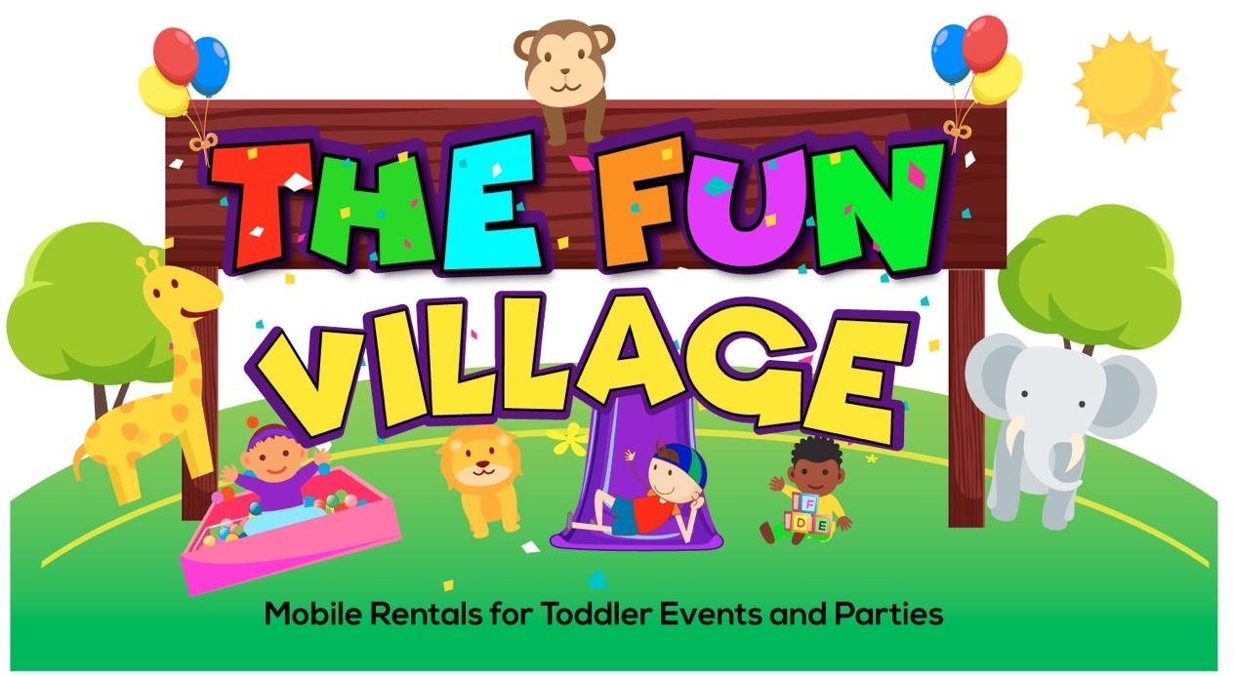

The Fun Village
Waiver Of Liability/Assumption Of Risk

In Exchange For Participation In Parties And Activities Organized By The Fun Village I , For Myself, My Child/Children Or Chaperone(s) Sign This Waiver And Assumption Of Risk In Consideration Of The Opportunity To Use The Equipment, Or To Participate In Any Parties Or Activities By The Fun Village.

I, Represent That I Am The Parent(s) Or Legal Guardian Of Or Guardian Of, Chaperone Of The Participants(s) Named Below Acknowledge And Understand That There Are Dangers And Risk Associated With The Use Of Equipment Supplied By The Fun Village And Agree To Assume Full Risk And Responsibility Of Personal Injury, Including The Potential Of Paralysis And Death. I Execute This Agreement On Behalf Of Participant(s) Named Below As Well As The Children Who Aren’t Here At The Time Of Signing.

I, For Myself, My Child/Children Or Chaperone(s) Agree To Follow The Safety Rules Provided And Acknowledge That Failure To Do So May Result In Termination Of The Use Of The Equipment. I Recognize That There Are Certain Inherent Risk Associated With The Use Of The Playground, Parties, And Activities. I Assume Full Responsibility On Behalf Of My Or Their Heirs, Assigns, Personal Representatives A Next Of Kin, HEREBY HOLD HARMLESS The Fun Village, It’s Owner(s), Members, Officers, Employees, Equipment Manufacturers And Sponsoring Agencies From All Liability For Any Such Personal Injury, Disability, Death, Or Loss Or Damage To Person Or Property To The Fullest Extent Of The Law.
This Waiver And Assumption Of Risk Form Shall Apply To ALL Risks, Known And Unknown, Even If Resulting From Negligent Actions Of Other Guests Or Employees Of The Fun Village.

I, For Myself, My Child/Children Or Chaperone(s) Understand That My Execution Of This Waiver On The Initial Visit Will Authorize The Fun Village To Enter This Waiver Into Its Database And Use It As A Continuous, Multi-Use Waiver For My Child/Children. I Hereby Expressly Authorize The Fun Village To Use This Waiver As A Multi-Use Waiver Until Such Time As I Revoke In Writing.

Participant’s Name __________________________ Birthday___________________ Age ___
Participant’s Name __________________________ Birthday___________________ Age ___
Participant’s Name __________________________ Birthday___________________ Age ___
Print Parent’s/Chaperone Of Child(ren) Name_____________________________
Signature Parent/Chaperone______________________________________
Emergency Contact Number________________________
Today’s Date________________

